Experimental study
object rotation
as a source of information for internal
structure of the subject
I.A. Miller
IJUS v19 2018

Abstract The work shows the results of exexperimental studies on the effects of rotational
rotating steel discs with different characteristics
theories of the internal structure on the system of
dioactive source - semiconductor detector
torus. It has been confirmed that the quality and meaning of the
information about the internal structure of the disks
are registered by this system, and, depending on
from the distance to the object of rotation, change their
values.

Analyzing the drafts of my research on the fifteenth
years ago, I came across an interesting workthe one whose results were never published. TO
unfortunately, only analysis and generalization remained available.
the obtained experimental results, and
the main primary results were lost. Whenfollowed the remaining analytical materials and topics
bits of primary data that have not yet been sold
fall, draw up a report on the principal opportunity
obtaining dependencies between the indications of the semiwater gamma spectrometer and certain hacharacteristics of the internal structure of the rotating
object.
Back in the zero years, for eight years, in his
free time from the main work, I introduced myself
the ability to conduct experimental research
for remote action of rotating
objects on the intensity of decay of point radioactive isotopes and semiconductor readings
detector (PPD). During this time, more
50 thousand measurements with various radioactive
sources (, and - emitters), various
objects of rotation and various recording
complexes. Based on the generalization of the obtained
experimental data were made as follows
important findings [1], [2], [3], [4], [5]:
- The intensity of the decay of point radioactive
source and RPM readings nonlinearly depend on
distance relative to a rotating object, from
speed and direction of rotation, , from the presence of "beating" axis of rotation and uneven rotational
Movement. When the angle appears the rotation axis
The magnitude of the effect of exposure to multiple increases.
- change in the dispersion of the sampling of the intensity of radioactive decay also depends on the above factors. The magnitude of the dispersion can serve
indicator of the impact of entropy processes in
The location of the point radioactive source.
- After turning off the rotation in the local space of the rotating object within a few days there remains amersion on the amount of dispersion and the formation of the distribution of the decay intensity
The studied isotope.
The idea of ​​the possible effect of entropy processes, both on the radioactive decay, and on
The dynamic characteristics of the PPD charges served as an experiment on verification
This hypothesis. The sources of comparative effects served three steel disks (applied alternately), sizes in diameter of 90 mm
and 5 mm thick. Mark steel - 40h. And the first disk was pulled out of the material not used
Earlier in the production, second and third discs after
Years of operation in extreme load mode.
In this case, the state of the internal structure and the corresponding characteristics of the first disk will be
Highly differ from the other two. At least
Extent, the degree of fatigue material.
As measuring equipment used semiconductor, GE (LI) -dector (DGDK
63B); preamplifier (Pug-2K); amplifier (Bui-3K)
and analyzer (AMA-02F1). Semiconductor detector, dot source of gamma radiation CS-137 (type
OSHA) and axis of rotation of the racor shaft of an asynchronous electric motor (AIR type, with a power of ~150 watt) are located on one vertical axis (Fig. 1). Rack
The electric motor was attached to the massive steel
table (~60 kg), and Dewar semiconductor vessel
The detector filled with liquid nitrogen (31 kg) was located on a soft platform, which prevented the transfer of minor vibration from the electric motor
To detector.

Motor shaft with a disk rotating with an angular speed of 6000 rpm, as counterclockwise,
So and clockwise (top view), was over
radioactive isotopic source on constant
Distance 20 mm. With such a large angular velocity of rotation of the disk (and the absence of "centering"), a strong beating was observed, i.e. Appeared an angle of nation
axis of rotation. The optimal distances from the radioactive source to the detector (depending on the maximum value of the experimentally obtained
Effect) amounted to 15 mm and 25 mm.

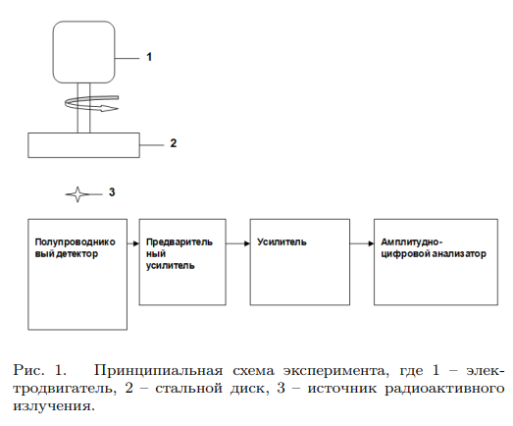
Rice. 1. Schematic diagram of experiment, where 1 - electric motor, 2 - steel disk, 3 - source of radioactive Radiation.

The area of ​​full absorption peak was measured
(peak) proportional to the number of registered
Gamma - quanta (pulses with PPD) Energy 661.6
CEV and general integral. Processing analyzed
The spectrum was conducted by the 'search' program developed in Dubna. This program for calculating s
- peak area, automatically puts tags in
Point "Inflection" of the distribution of Gauss, which allows
Observe identical conditions in the process of calculating the following measurements. Energy width
The resolutions of the studied peaks did not exceed 3 keV.
In one hour of measurements, the drift of the center of the severity of the peak in
The side of increasing or lowering did not exceed 0.5
keV. Measuring the peak and integral took place in two
modes, 60 measurements when engine operation and 60
Measurements after it is turned off and stopping the rotation. "Live" time of one measurement was 35-
40 s, spectrum processing time 35 s. Peak Square B.
Static measurement mode, depending on the point
Measurements, was ~ 11000-12000 pulses with an average
Standard deviation σ = 294 pulse.
When analyzing experimental results, changes in the values ​​of the empirical parameter were investigated
- relative difference in average area values
peaks measured in static mode (sst) and mode
rotation (srot) disk:

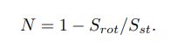
The use of this relationship is due to
that the measured average peak value in rotation mode was always less than the average peak area in
static mode. The relative value of the test parameter gives the base to learn remote
The effect of rotation of the disk at different distances
From the detector to the system disk system. In this case
changes in the location of the radioactive source (in
depending on the distance from the detector) will not
influence the accuracy of experimental
Results. It is known that the magnitude of the impact on
The intensity of the decay of radioactive isotopes is due to the location relative to the rotating object [1], [2], [3], [4], [5]. Therefore, permanent
Distance from disc to the source of gamma radiation
in all measurements allows you to bind the studied
Remote impact only on the detector, i.e.
On the dynamic characteristics of the collection and adhesion of nonequilibrium charges of PPDs [3], [5]. Here
We are able to maximize the impact as much as possible.
changes in the intensity of decomposition (depending on
Distances) on the instrument reading.

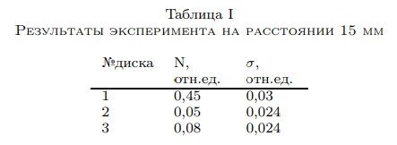

Table I.
Experiment results at a distance of 15 mm

The studies have revealed the most information modes of exposure to rotation: this
Distances from the source to detector - 15 mm and 25 mm
In rotation mode counterclockwise. At a distance of 15 mm, the greatest effect of exposure was provided
Disc # 1, made of new material (see table).
The effect of exposure to the other two disks was very insignificant, in which the relative parameter (N) was distinguished from the first disk to more
than 15 standard deviations. Obvious is observed
The dependence of this parameter from the internal wear
Metal.
In turn, the internal structure of the material
Characterized by the interatomic distance. To determine the interatomic distance in the crystal
The grille of each disk was used x-ray -
The diffraction method on the installation of Drone-2.0 with the radiation wavelength λ = 1.54178 ˚A. At
Comparison of the relative parameter of the disks with the size of the interatomic distance was obtained linear (exponential) dependence with the largest
correlation correspondence only for distance
From the source to a 25 mm detector (Fig. 2). In fig. 2.
It can be seen that the magnitude of the interatomic distance does not depend on the degree of fatigue of the metal
Basically change the interatomic distance in metals of one brand
depends on the presence of various microprines yet
At the time of smelting. The conducted X-ray structural analysis of the second and third sample noted the selection
γ-iron in sample number 2 (~ 5-7%) and the decay of γ-iron with
The formation of carbides in sample number 3.

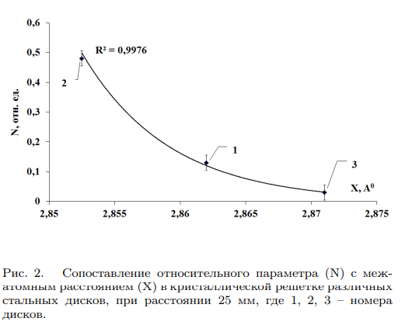

[Rice. 2. Comparison of the relative parameter (N) with the interatomic distance (x) in the crystal lattice of various
Steel disks, at a distance of 25 mm, where 1, 2, 3 - numbers
disks.]

Thus, on the basis of the presented search research, several preliminary conclusions can be made:
- the rotating material object in the local spatial volume generates a non-electromagnetic field carrying information about the internal
The structure of this rotation object.
- the quality and meaning of the generated information about
internal structure varies depending on
Distances to the object of rotation.
- The system of radioactive source - PPD can be used as a sensor of information about
The internal structure of the rotating object.

Bibliography
[1] Melnik I.A. Experimental effects of influence
The rotating fluid on the radiation intensity of the radioactive isotope. Izv. universities. Physics, (10): 56-59,
2003.
[2] Melnik I.A. Experimental impact detection
rotation on the statistical distribution of the hardware
The spectrum of gamma radiation isotopes. Izv. universities. Physics,
(5): 19-26, 2004.
[3] Melnik I.A. Experimental Research Review
The remote influence of rotating objects on the semiconductor detector and the radioactive decay. Consciousness
and physical reality, (6): 12-26, 2005.
[4] Melnik I.A. Exposure studies of the electric motor
on statistical fluctuations of radioactive decay. Izv.
universities. Physics, (4): 32-38, 2006.
[5] Melnik I.A. Remote impact of rotation on
Nonequilibrium quantum systems // FIR. Tr. The VII of the Siberian Interdisciplinary Conference on Mathematical Problems of Space-Time Physics of Complex Systems dedicated to the 100th anniversary of the report of the Minkowskiy 'space and time'. Novosibirsk, September 21-24, 2008 -
Novosibirsk: Academic Publishing House "Geo ', 2010, p. 191-203.
[1] Мельник И.А. Экспериментальные исследования влияния
вращающейся жидкости на интенсивность излучения радиоактивного изотопа. Изв. вузов. Физика, (10):56–59,
2003.
[2] Мельник И.А. Экспериментальное обнаружение воздействия
вращения на статистическое распределение аппаратурного
спектра гамма-излучения изотопов. Изв. вузов. Физика,
(5):19–26, 2004.
[3] Мельник И.А. Обзор экспериментальных исследований по
дистанционному влиянию вращающихся объектов на полупроводниковый детектор и радиоактивный распад. Сознание
и физическая реальность, (6):12–26, 2005.
[4] Мельник И.А. Исследования воздействия электродвигателя
на статистические флуктуации радиоактивного распада. Изв.
вузов. Физика, (4):32–38, 2006.
[5] Мельник И.А. Дистанционное воздействие вращения на
неравновесные квантовые системы // Избр. тр. VII Сибирской междисциплинарной конференции по математическим проблемам физики пространства-времени сложных систем, посвященной 100-летию доклада Г. Минковского ’Пространство и время’. Новосибирск, 21-24 сентября 2008 г. -
Новосибирск: Академическое изд-во ’Гео’, 2010, с. 191-203.

